
Product Specification

1.0 PRODUCT DETAILS

PRODUCT NAME | Leader Memphis Chicken Bites 6 x 1kg |  |  | Piece Weight | Approx.35g
PRODUCT DESCRIPTION | Succulent chicken bites, coated in a Memphis BBQ style seasoning and covered in a crispy crumb.
LEADER PRODUCT CODE | 1100682 | CUSTOMER PRODUCT CODE (if applicable) | N/A
STORAGE & DISTRIBUTION CONDITION  (Frozen, Chilled, ambient) | Frozen at or below minus 18°C
PRODUCT CLAIM | NIL
COUNTRY OF ORIGIN | Made in New Zealand from local and imported ingredients.

2.0 INGREDIENTS DECLARATIONS (FSANZ Standard 1.2.4)

Chicken (56%), Memphis Batter (17%) [Water, Wheat Flour, Thickeners (412, 1404), Maize Starch, Salt, Dehydrated Onion, Hydrolysed Vegetable Protein (Wheat), Spice, Herb, Seasoning (Sugar, Dehydrated Vegetables, Salt, Acidity Regulators (262, 330), Fructose, Worcestershire Sauce Powder (Maltodextrin (Maize), Vegetable Protein Extract (Maize), Vinegar, Sugar, Salt, Molasses, Garlic, Acidity Regulator (330), Spices, Rice Bran Oil)), Spices, Flavours, Colour (150a), Yeast Extract], Water, Memphis Breadcrumb (12%) [Wheat Flour, Herb, Spice, Yeast, Salt, Colours (150a, 160c, 160b, 100), Wheat Gluten, Sugar, Canola Oil, Dehydrated Vegetables, Acidity Regulators (262, 330), Fructose, Worcestershire Sauce, Flavours, Spices, Yeast Extract, Emulsifier (471)], Vegetable Oil, Soy Protein Isolate, Textured Soy Protein, Seasoning [Emulsifier (451), Hydrolysed Vegetable Protein (Soy), Flavour Enhancer (920)], Dehydrated Onion, Emulsifiers (450, 451), Salt, Ground White Pepper.
ALLERGY STATEMENT:
CONTAINS: GLUTEN, WHEAT, SOY.
MAY CONTAIN: MILK, EGG, FISH, CRUSTACEAN, SULPHITES.

3.0 CHARACTERISING INGREDIENTS (FSANZ Standard 1.2.10)
CHARACTERISING INGREDIENT(S) | PRODUCT INGREDIENT | % QUANTITY IN FINAL PRODUCT
List the characterising ingredient(s) as  - appears in the name of the food  - or is usually associated with the name of the food by the consumer  - or is emphasised on the label in words or pictures | Chicken | 56%

4.0 NUTRITION INFORMATION PANEL (NIP) (FSANZ Standard 1.2.8)
NUTRITION INFORMATION
Units per Pack: Approx. 28
Servings per Pack: Approx. 9
Serving size: 105g (3 Bites)
 | Average Quantity per Serving | Average Quantity per 100g
Energy (kJ) | 910 | 867
Protein (g) | 11.6 | 11.0
Fat, Total (g) | 12.0 | 11.4
- Saturated (g) | 3.8 | 3.6
Carbohydrate (g) | 15.0 | 14.3
- Sugars (g) | 5.9 | 5.6
Dietary Fibre (g) | 2.0 | 1.9
Sodium (mg) | 597 | 569
HEALTH STAR RATING | 

5.0 SHELF LIFE (FSANZ Standard 1.2.5)

What is the shelf life of the product? | 18 months
Where can customers find the Date Marking on the product?  Mark (X) | ON CARTON | ON PRODUCT PACK FOR DISPLAY
Best Before | X | X

6.0 PHYSICAL PRODUCT SPECIFICATIONS

 | APPROX. DIMENSIONS
Length (mm) | 48 - 52
Width (mm) | 40 - 44
Height (mm) | 18 - 22
Diameter (mm) | N/A
Target Weight (g) cannot be less than label weight | 35g
Insert product photo without primary packaging (on a grid)  (Uncooked/Cooked) | 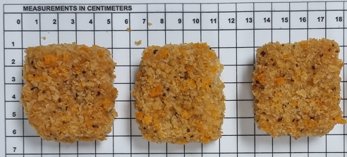
Insert cross sectional view of product (cut product into half)  (Uncooked/Cooked) | 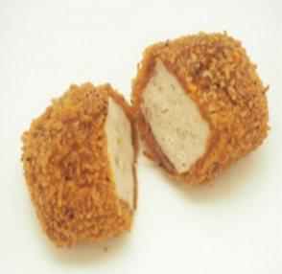
Insert product photo with primary packaging (e.g. packed in tray, carton etc) | 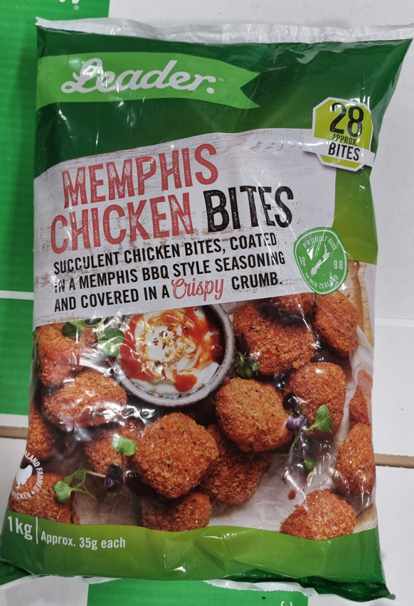

7.0 ORGANOLEPTIC SPECIFICATIONS
(Examples may include appearance, flavour, colour, aroma, texture etc)
TEST/PARAMETER | SPECIFICATION | TEST METHOD
Appearance | Square bite sized pieces with brown coating. | Visual
Colour | Brown coating with specs of seasoning. | Visual
Texture | Tender, succulent, moist inside with a firm bite and thin coating on the outside. | Taste
Flavour | Chicken encased in a delicious Memphis coating. | Taste

8.0 COOKING INSTRUCTIONS
Product must be cooked prior to consumption.
Remove product from packaging and cook from frozen
Recommended centre temperature 75◦C.
Allow product to cool for 2mins prior to consuming.

Oven Bake: | Preheat oven to 190°C. Fan Bake for approx. 15 mins.
Deep Fry: | Preheat oil to 175°C. Cook for 6-7mins.
Air Fry (1800W): | Cook at 200°C for approx. 8 mins.

All appliances vary. These are guidelines only.

9.0 MICROBIOLOGICAL SPECIFICATIONS
TEST/PARAMETER | SPECIFICATION
Standard Plate Count cfu/g | <5,000,000
E. coli cfu/g | <10
Salmonella ssp 25/g | Absent
Coagulase positive Staphylococcus cfu/g | <1,000
B. cereus cfu/g | <1,000
Campylobacter cfu/g | Absent
Faecal Coliforms cfu/g | <1,000
C.perfringens cfu/g | <1,000
Standard Plate Count cfu/g | <5,000,000

10.0 PACKAGING SPECIFICATIONS
 | CARTON
Carton name (e.g. Small, large, etc) | All purpose
Carton Weight(g) | 253g
Carton Dimensions (L x W x H) | 400mm x 253mm x 158mm
Material / Packaging type for primary packaging | Printed Film
Material / Packaging type for secondary packaging | Cardboard
Net carton Weight with Product (kg) | 6Kg
Packaging configuration/ tray configuration (Quantity) | 6 x 1kg
AEN code (inner) | 9420064503155
TUN code (outer) | 19420064503145
Internal Palletising information

New Zealand
Number of Layers on pallet | 7 | Number of cartons per layer | 10 | Total number of cartons per pallet | 70
Australia
Number of Layers on pallet | N/A | Number of cartons per layer | N/A | Total number of cartons per pallet | N/A

11.0 CONTACT DETAILS:
Manufactured By:
Food Partners Ltd
50 Luke Street, Otahuhu,
Auckland, 1062, New Zealand

Australian Distributor:
Patties Foods Pty Ltd
Level 2, 1 Joseph Avenue,
Mentone, VIC, 3194, Australia

NZ Customer Queries: (09) 276 3879

Australia Customer Queries: 1800 650 069

 | Name: | Version: | Date:
Completed By: | Kimaya More | 2 | 21/09/2022
Authorised By: | Kaeslin Rodrigues | 2 | 21/09/2022

