
Product Specification

1.0 PRODUCT DETAILS

PRODUCT NAME | Leader Crumbed Chicken Pattie 35 ×100g |  | Piece Weight | 100g
PRODUCT DESCRIPTION | Chicken meat(ground) mixed with seasoning and then coated in crispy golden crumb
LEADER PRODUCT CODE | 1050035 | CUSTOMER PRODUCT CODE (if applicable) |  |  | N/A
STORAGE & DISTRIBUTION CONDITION  (Frozen, Chilled, ambient) | Frozen below minus18°C
PRODUCT CLAIM | NIL

2.0 INGREDIENTS DECLARATIONS (FSANZ Standard 1.2.4)
Chicken (49%, ground), Batter [Wheat Flour, Thickener (1404), Maize Starch, Salt, Thickener (412), Dehydrated Onion, Hydrolysed Vegetable Protein (Wheat), Spice, Herb], Breadcrumbs [Wheat Flour, Glucose, Salt, Yeast, Colour (100, 160b)], Water, Seasoning [Soy Protein, Emulsifier (451), Anti Caking Agent (551), Garlic Flavour], Vegetable Oil, Soy Protein Isolate.
ALLERGY STATEMENT:
CONTAINS: GLUTEN, WHEAT, SOY.
MAY CONTAIN: MILK, EGG, FISH, CRUSTACEAN, SULPHITES.

3.0 CHARACTERISING INGREDIENTS (FSANZ Standard 1.2.10)
CHARACTERISING INGREDIENT(S) | PRODUCT INGREDIENT | % QUANTITY IN FINAL PRODUCT
List the characterising ingredient(s) as  - appears in the name of the food  - or is usually associated with the name of the food by the consumer  - or is emphasised on the label in words or pictures | Chicken | 49%

4.0 NUTRITION INFORMATION PANEL (NIP) (FSANZ Standard 1.2.8)

NUTRITION INFORMATION
Servings per pack: 35
Serving size: 100g (1 Schnitzel)
 | Average Quantity per Serving | % Daily Intake per Serving* | Average Quantity per 100g
Energy (kJ) | 798 | 9% | 798
Protein (g) | 12.5 | 25% | 12.5
Fat, Total (g) | 8.3 | 12% | 8.3
- Saturated (g) | 2.6 | 11% | 2.6
Carbohydrate (g) | 16.3 | 5% | 16.3
- Sugars (g) | 0.3 | 0.4% | 0.3
Dietary Fibre (g) | 3.7 | 12% | 3.7
Sodium(mg) | 575 | 25% | 575
*% Daily Intakes are based on an average adult diet of 8700kJ.
HEALTH STAR RATING | 

5.0 SHELF LIFE (FSANZ Standard 1.2.5)

What is the shelf life of the product? | 18 months
Where can customers find the Date Marking on the product?  Mark (X) | ON CARTON | ON PRODUCT PACK FOR DISPLAY
Best Before | X | NA

6.0 PHYSICAL PRODUCT SPECIFICATIONS

 | APPROX DIMENSION
Length (mm) | 108-112
Width (mm) | 73-77
Height (mm) | 8-
Diameter (mm) | NA
Target Weight (g) cannot be less than label weight | 100
Insert product photo without primary packaging (on a grid) | 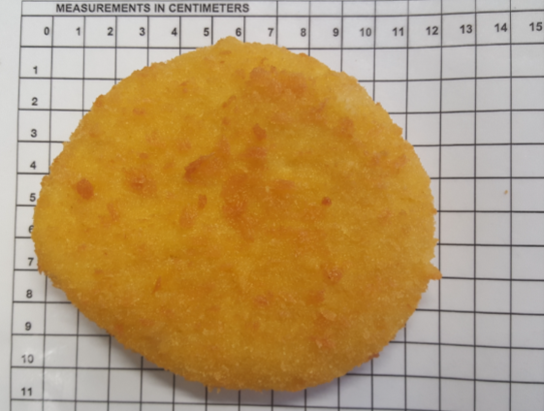
Insert cross sectional view of product (cut product into half) | 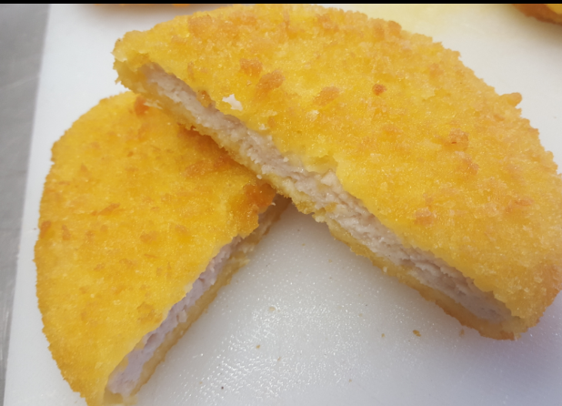

7.0 ORGANOLEPTIC SPECIFICATIONS
(Examples may include appearance, flavour, colour, aroma, texture etc)
TEST/PARAMETER | SPECIFICATION | TEST METHOD
Appearance | Crumbed chicken cutlets evenly coated | Visual
Colour | Golden brown chicken meat | Visual
Texture | Crispy crumb. Moist and tender meat | Taste
Flavour | Chicken flavour lightly savoury, seasoned plain crumb | Taste

8.0 COOKING INSTRUCTIONS
Product is not fully cooked. Product requires cooking before consumption to an internal temperature>75◦C.

Oven Bake: | Preheat oven to 180◦C, fan bake approximately 5-7 mins per side
Pan Fry: | On medium heat for approx. 7 mins per side

9.0 MICROBIOLOGICAL SPECIFICATIONS
(As per MOH guidelines 1995, as appropriate for the product)

TEST/PARAMETER | SPECIFICATION
Standard Plate Count cfu/g | 5,000,000
Salmonella ssp /25g | Absent
Coagulase positive Staphylococcus cfu/g | 1,000
B. cereus cfu/g | 1,000
Yeast & Mould cfu/g | 10,000
Campylobacter cfu/g | Absent
Coliforms cfu/g | 1,000
C.perfringens cfu/g | 1,000

10.0 PACKAGING SPECIFICATIONS
 | CARTON
Carton name (e.g. Small, large, etc) | G-Small
Carton Weight(g) | 192
Carton Dimensions (L x W x H) | 34cm x 24cm x 10cm
Material / Packaging type for primary packaging | Clear liner film
Material / Packaging type for secondary packaging | Cardboard
Net carton Weight with Product (kg) | 3.5kg
Packaging configuration/ tray configuration (Quantity) | 35 x 100g
AEN code (inner) | NA
TUN code (outer) | 19421009433701
Internal Palletising information

Number of Layers on pallet | 10 | Number of cartons per pallet | 13 | Total number of cartons per pallet | 130

11.0 CONTACT DETAILS:
Manufactured By:
Food Partners Ltd
50 Luke Street, Otahuhu,
Auckland, 1062, New Zealand

Australian Distributor:
Patties Foods Pty Ltd
Level 2, 1 Joseph Avenue,
Mentone, VIC, 3194, Australia

NZ Customer Queries: (09) 276 3879

Australia Customer Queries: 1800 650 069

 | Name: | Version: | Date:
Completed By: | Kimaya More  Jr Food Technologist | 4 | 27/02/2024
Authorised By: | Kaeslin Rodrigues  Product Technologist | 4 | 27/02/2024

